**AUDIO - VISUAL SPEECH RECOGNITION**

**Team Members:**

Tejaswi Kottakki – 2010030088

Harika Nethi – 2010030119

Shreya Chintawar – 2010030155

Amrutha Varshini – 2010030009

**REPORT -3**

* We’ve implemented a module for converting speech to text. Main objective of this module is to implement Speaker recognition under noisy and unconstrained conditions

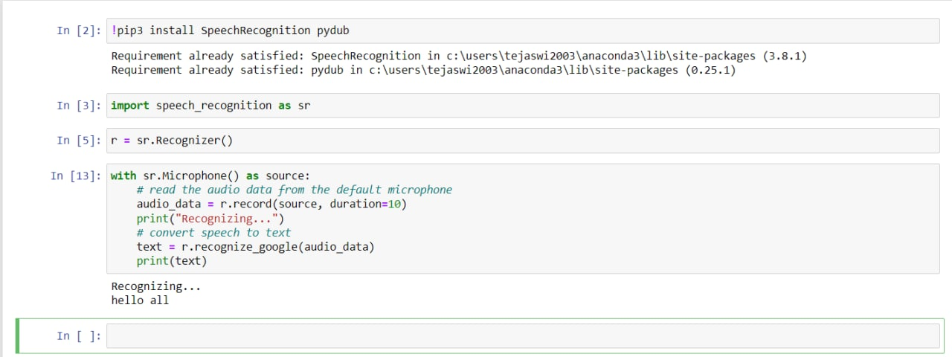

Here, the recognized text is printing in the console.

After running the program, whatever the speaker speaks in the 7 seconds of time period, the program will convert that speech to text form and print it in the console.

Now, we modified the code to print the recognized text to a text file.

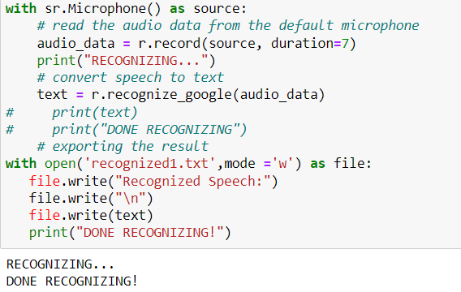

recognized1.txt

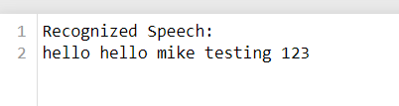

* The other module which we’ve implemented is converting the audio from a given video file to text and printing it to a text file.

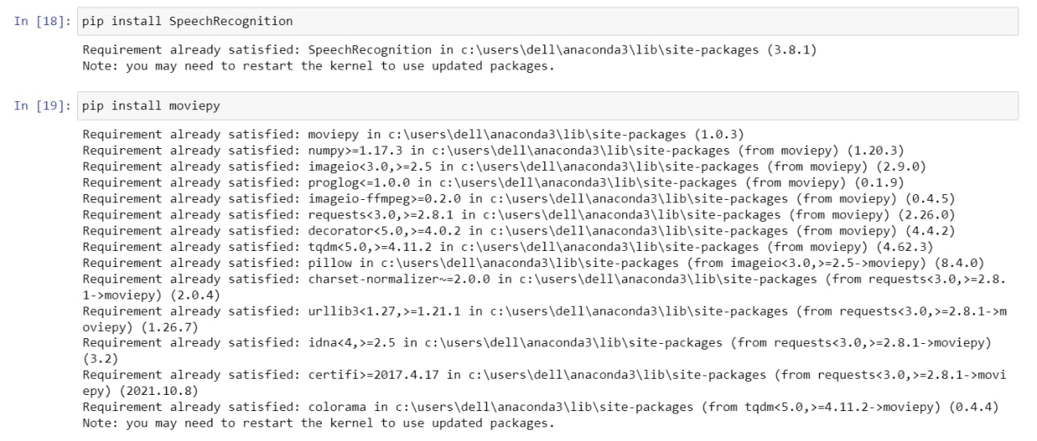

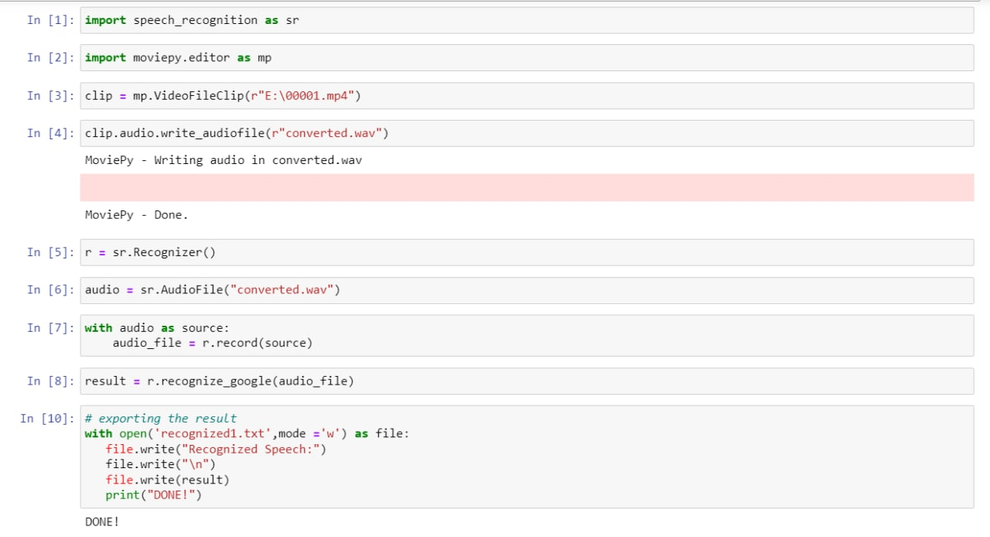

recognized1.txt

